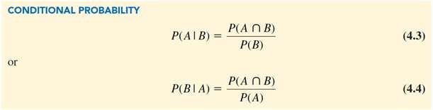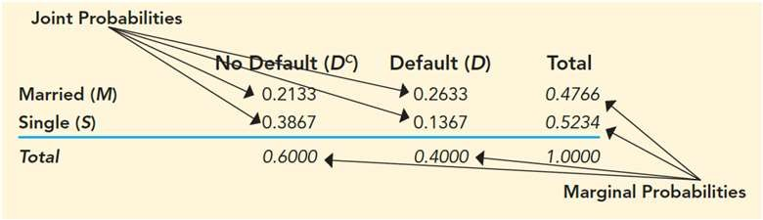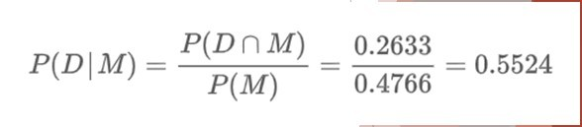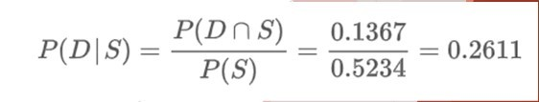

Conditional Probability

**Formulas**

**Conditional Probabilities**

**Probability of Defaulting, Given the person is married:**

**Joint and Marginal Probabilities**

**Probability of Defaulting, Given the person is single:**

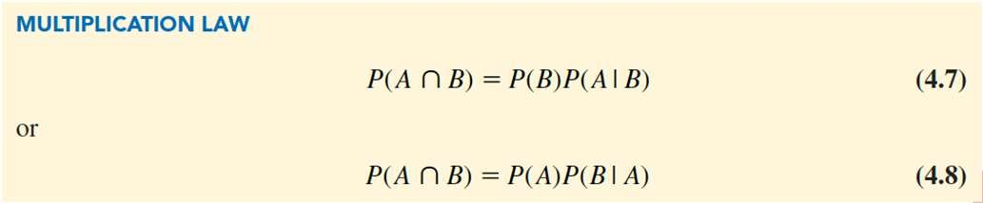

Conditional Probability

**Multiplication Law:**

◆ **Multiplication law** can be used to calculate the probability of the intersection of two events.

◆ Based on the definition of conditional probability.

◆ Rearrange formula to solve for P(A n B)

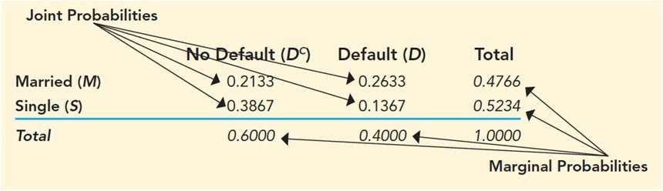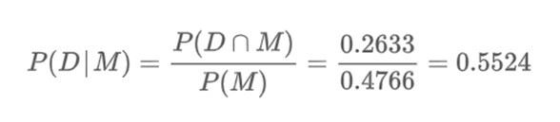

**Multiplication Law:**

**Example:**

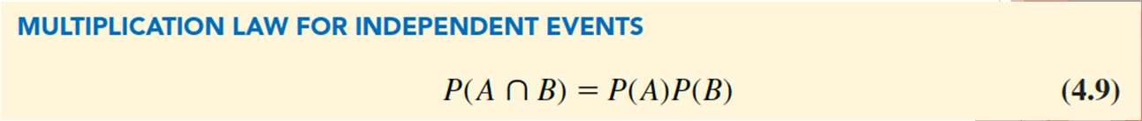

Conditional Probability

◆ Special case in which events *A* and *B* are independent.

◆ To compute the probability of the intersection of two independent events

◆ Simply multiply the probabilities of each event.

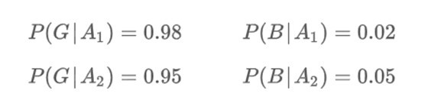

Conditional Probability

Historical data suggest the quality ratings of the two suppliers:

◆ This new information allows us to update the prior probabilities.

◆ To do so, we calculate conditional probabilities



Conditional Probability

**Bayes’ Theorem:**

◆ Way to update probabilities when we learn new information

◆ Example: A manufacturing firm receives shipments of parts from two different suppliers:

◆ 65% of the parts purchased from supplier 1.

◆ 35% of the parts purchased from supplier 2.

◆ These are called **Prior Probabilities**

◆ estimates for specific events of interest

|  |  |  |
| --- | --- | --- |
|  | **% Good Parts** | **% Bad Parts** |
| **Advance Auto (A1)** | 98 | 2 |
| **Auto Zone (A2)** | 95 | 5 |

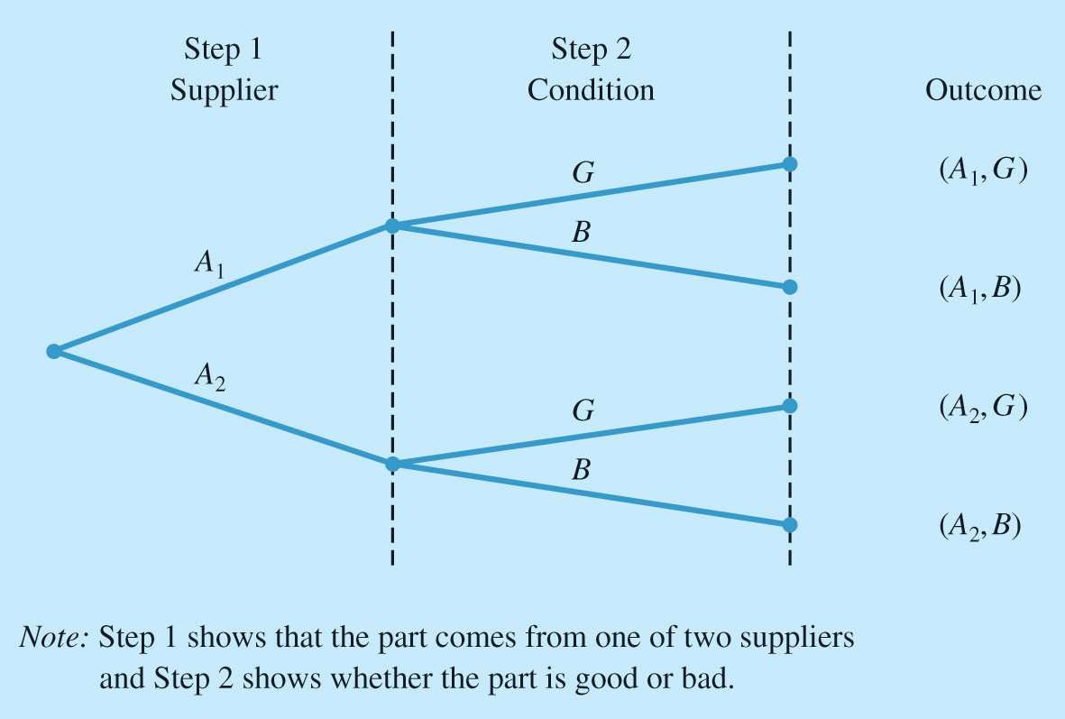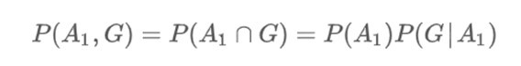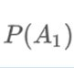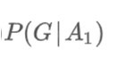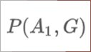

Conditional Probability

Diagram for Two-Supplier Example

◆ There are 4 possible outcomes:

◆ Each outcome is the intersection of 2 events

◆ Example: Probability of getting a good part from Advanced Auto

◆ We use the multiplication rule to calculate

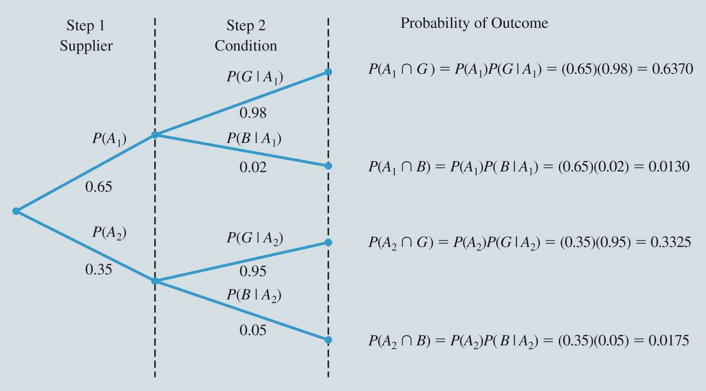

Conditional Probability

Figure 4.8: Probability Tree for Two-Supplier Example

Prior X Update = Probability of Outcome

◆ Simply multiply the probabilities of each branch to calculate the probability

of the outcome.



Conditional Probability

◆ Suppose the parts from the two suppliers are used in the firm’s manufacturing process and a machine breaks while attempting the process using a bad part:

◆ Given the information that the part is bad, what is the probability that it came from supplier 1 and what is the probability that it came from supplier 2?

◆ That is: What is

◆ P(A1|B) = ?

◆ P(A2|B) = ?

◆ Using the prior probabilities and the conditional probabilities to update them, we can use Bayes Rule to calculate P(A1|B) and P(A2|B)

◆ Known as **Posterior Probabilities**

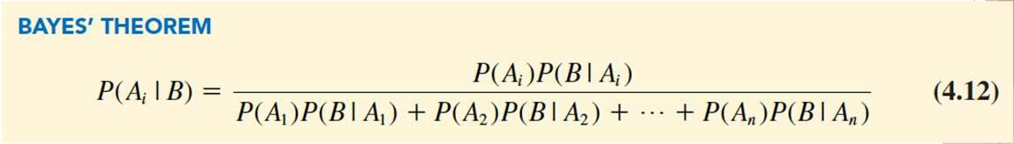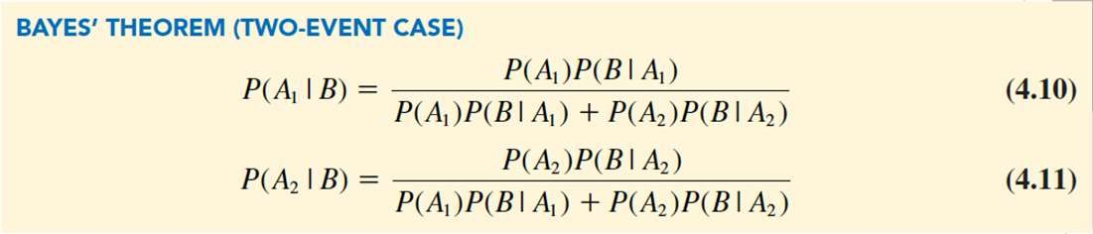

Conditional Probability

◆ Bayes’ theorem is applicable when are mutually exclusive and their union is the entire sample space.

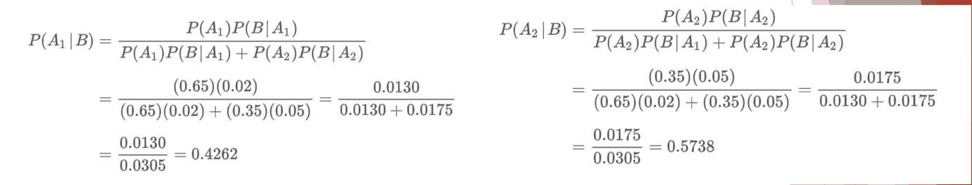

Bayes Theorem



Random Variables

Discrete Random Variables Continuous Random Variables

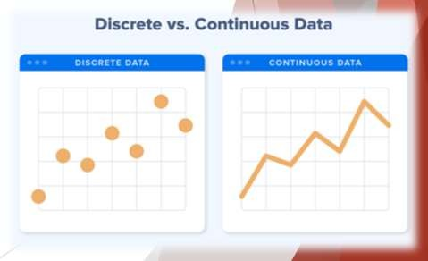

Random Variables

◆ A **random variable**

◆ is a numerical description of the outcome of a random experiment.

◆ Random variables are quantities whose values are not known with certainty.

◆ A random variable can be classified as being either:

◆ Discrete.

◆ Continuous.



Random Variables

◆ **Why are they called Random Variables?!?**

◆ A random variable is neither random, nor a variable!

◆ **Examples:**

◆ the number of children in a family

◆ the Friday night attendance at a cinema

◆ the number of patients in a doctor's surgery

◆ the number of defective light bulbs in a box of ten

**Could there be patterns, reasons, or conscious decisions related to these “phenomena”?**



Random Variables

Table 4.7: Examples of Discrete Random Variables – only take on specified discreet values

|  |  |  |
| --- | --- | --- |
| **Random Experiment** | **Random Variable (*x*)** | **Possible Values for the Random Variable** |
| Flip a coin | Face of a coin showing | 1 if heads; 0 if tails |
| Roll a die | Number of dots showing on top of die | 1, 2, 3, 4, 5, 6 |
| Contact five customers | Number of customers who place an order | 0, 1, 2, 3, 4, 5 |
| Operate a health care clinic for one day | Number of patients who arrive | 0, 1, 2, 3, … |
| Offer a customer the choice of two products | Product chosen by customer | 0 if none; 1 if choose product A; 2 if choose product B |

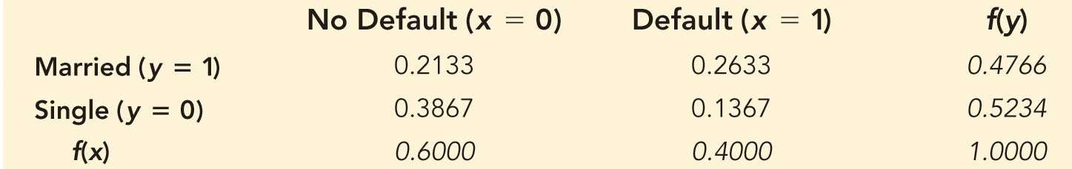

Random Variables

◆ Lancaster Savings and Loan Example

◆ Random Variable **x = 1** for Default on Mortgage or **x = 0** for No Default

◆ Random Variable **y = 1** for Married or **y = 0** for Single

◆ Random Variable **z = number of payments per year** (= 12 for 12 months)

Table 4.8: Joint Probability Table for Customer Mortgage Prepayments

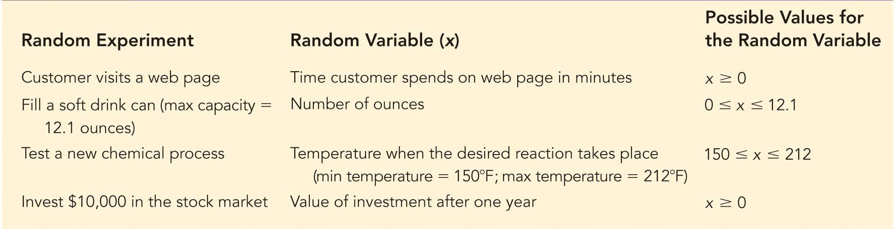

Random Variables

**Continuous Random Variables:**

◆ A random variable that may assume any numerical value in an interval or collection of intervals

◆ Relatively few random variables are truly continuous

◆ Many discrete random variables have a large number of potential outcomes

◆ can be effectively modeled as continuous random variables.



Discrete Probability Distributions

Custom Discrete Probability Distribution Expected Value and Variance

Discrete Uniform Probability Distribution Binomial Probability Distribution

Poisson Probability Distribution

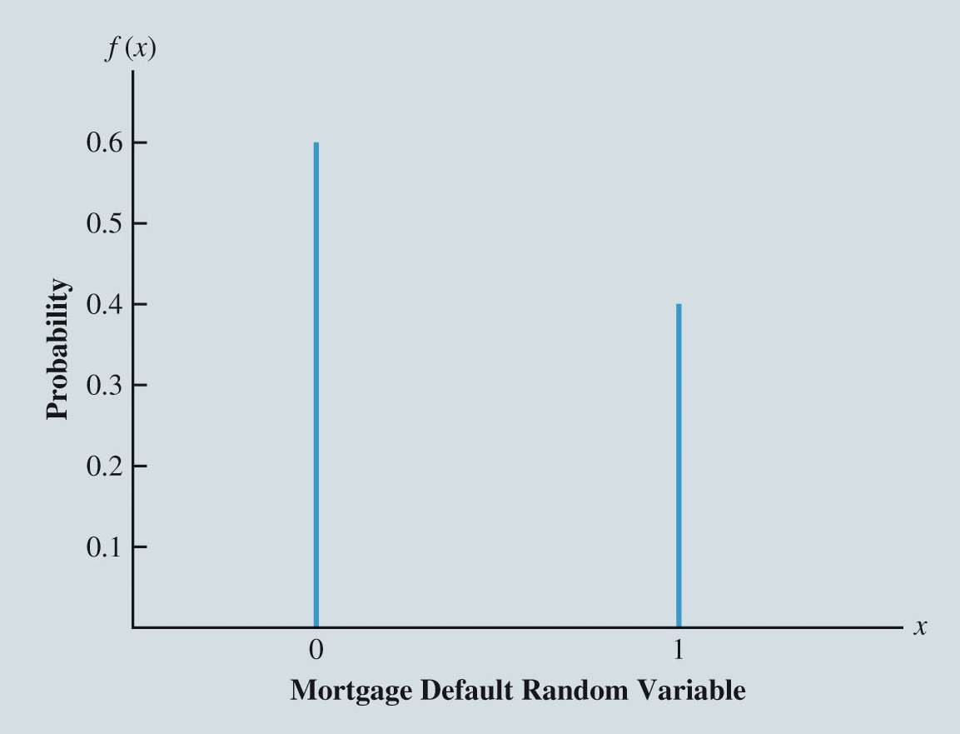

Discrete Probability Distributions

◆ The **probability distribution** for a random variable

◆ describes the range and relative likelihood of possible values for a random variable.

◆ For a discrete random variable *x*, the probability distribution is defined by the **probability mass**

**function**, denoted by

*f* (*x*).

◆ The probability mass function provides the probability for each value of the random variable.

Probability Distribution for Whether a Customer Defaults on a Mortgage

◆ f(0) = .6

◆ f(1) = .4

Requirements:

◆ 𝑓 𝑥 ≥ 0

◆ ∑ 𝑓 𝑥 = 1

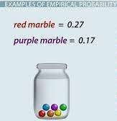

Discrete Probability Distributions

◆ **Empirical Probability Distribution**

◆ A probability that is generated from observations

◆ is considered a **custom discrete probability distribution** if:

◆ it is discrete

◆ the possible values of the random variable have different values:

Useful for describing different possible scenarios that have different probabilities.

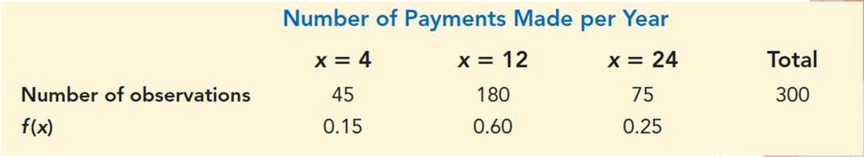

Discrete Probability Distributions

◆ Example: Lancaster Savings and Loan Example

◆ The random variable describing the number of mortgage payments made per year by randomly chosen customers.

Table 4.10: Summary Table of Number of Payments Made per Year

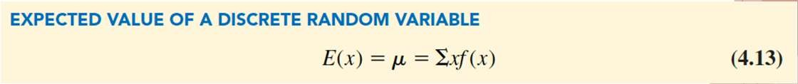

Discrete Probability Distributions

Expected Value and Variance:

◆ The **expected value**, or mean, of a random variable

◆ is a measure of the central location for the random variable.

◆ The weighted average of the values of the random variable, where weights are probabilities

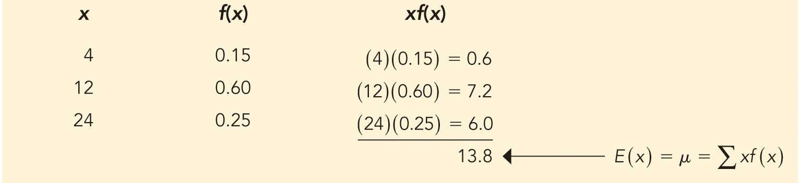

Discrete Probability Distributions

Expected Value for Number of Payments Made per Year by a Lancaster Savings and Loan Mortgage Customer

If Lancaster Savings and Loan signs a new mortgage customer, the expected number of payments per year for this customer is 13.8.

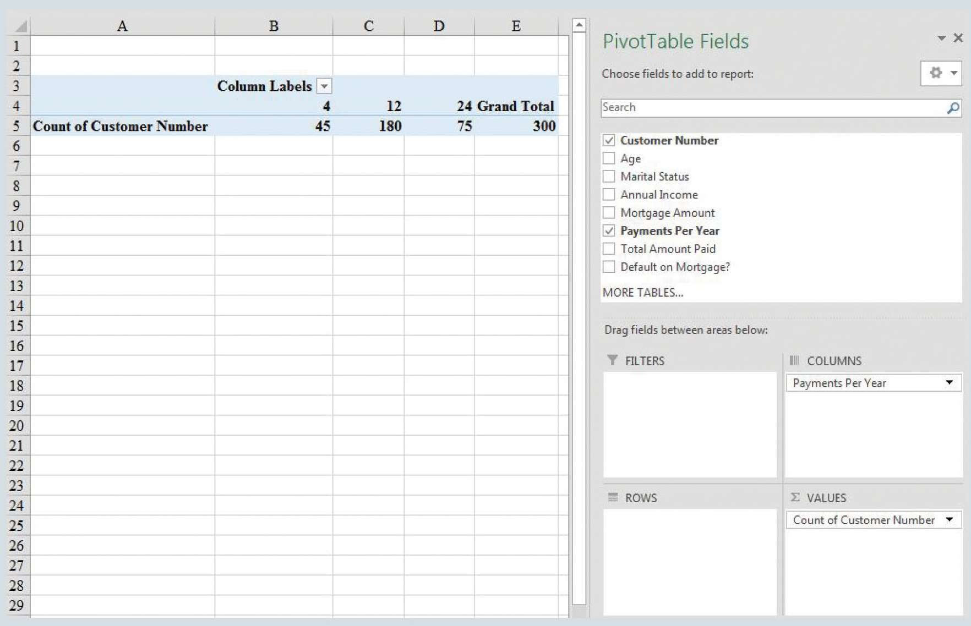

Discrete Probability Distributions

Figure 4.10: Excel PivotTable for Number of Payments Made per Year

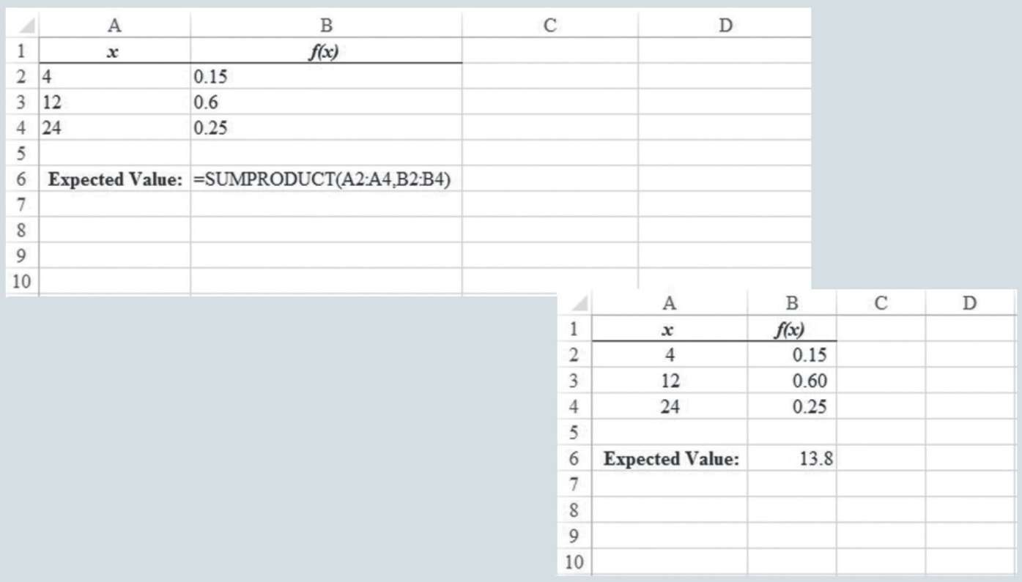

Discrete Probability Distributions

Figure 4.11: Using Excel SUMPRODUCT Function to Calculate the Expected Value for Number of Payments Made per Year by a Lancaster Savings and Loan Mortgage Customer

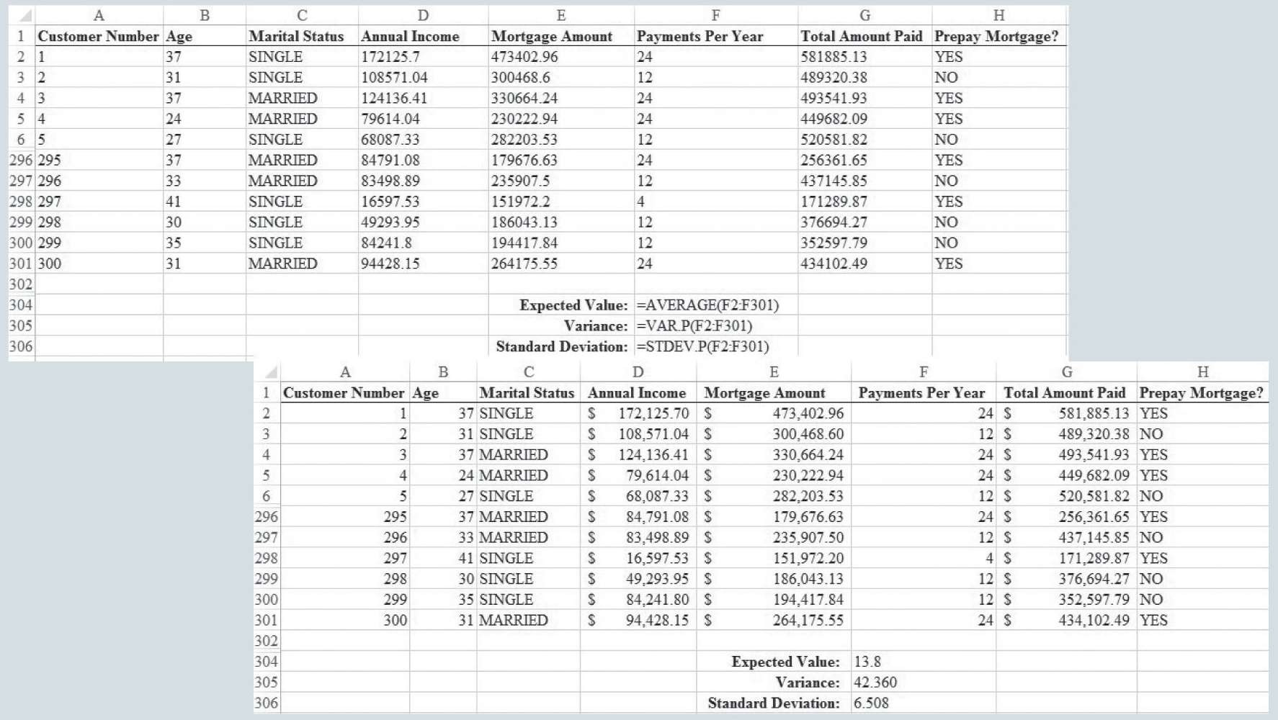

Discrete Probability Distributions

Figure 4.12: Excel Calculation of the Expected Value for Number of Payments Made per Year by a Lancaster Savings and Loan Mortgage Customer

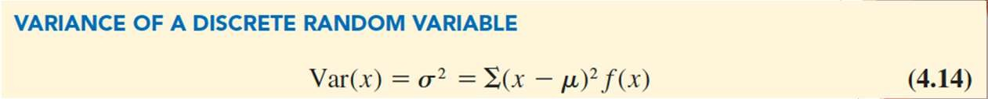

Discrete Probability Distributions

◆ **Variance** is a measure of variability in the values of a random variable:

◆ An essential part of the variance formula is the deviation, 𝑥 − 𝜇,

◆ which measures how far a particular value of the random variable is from the expected value, or mean, 𝜇.

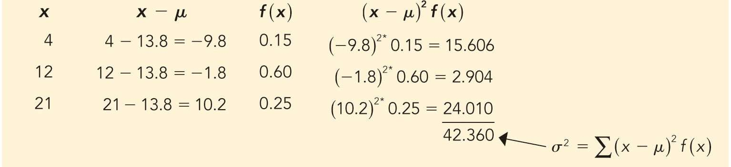

Discrete Probability Distributions

Calculation of the Variance for Number of Payments Made per Year by a Lancaster Savings and Loan Mortgage Customer

* The standard deviation, 𝜎, is defined as the positive square root of the variance.
* The standard deviation for the payments made per year by a mortgage customer is

42.360 = 6.508.

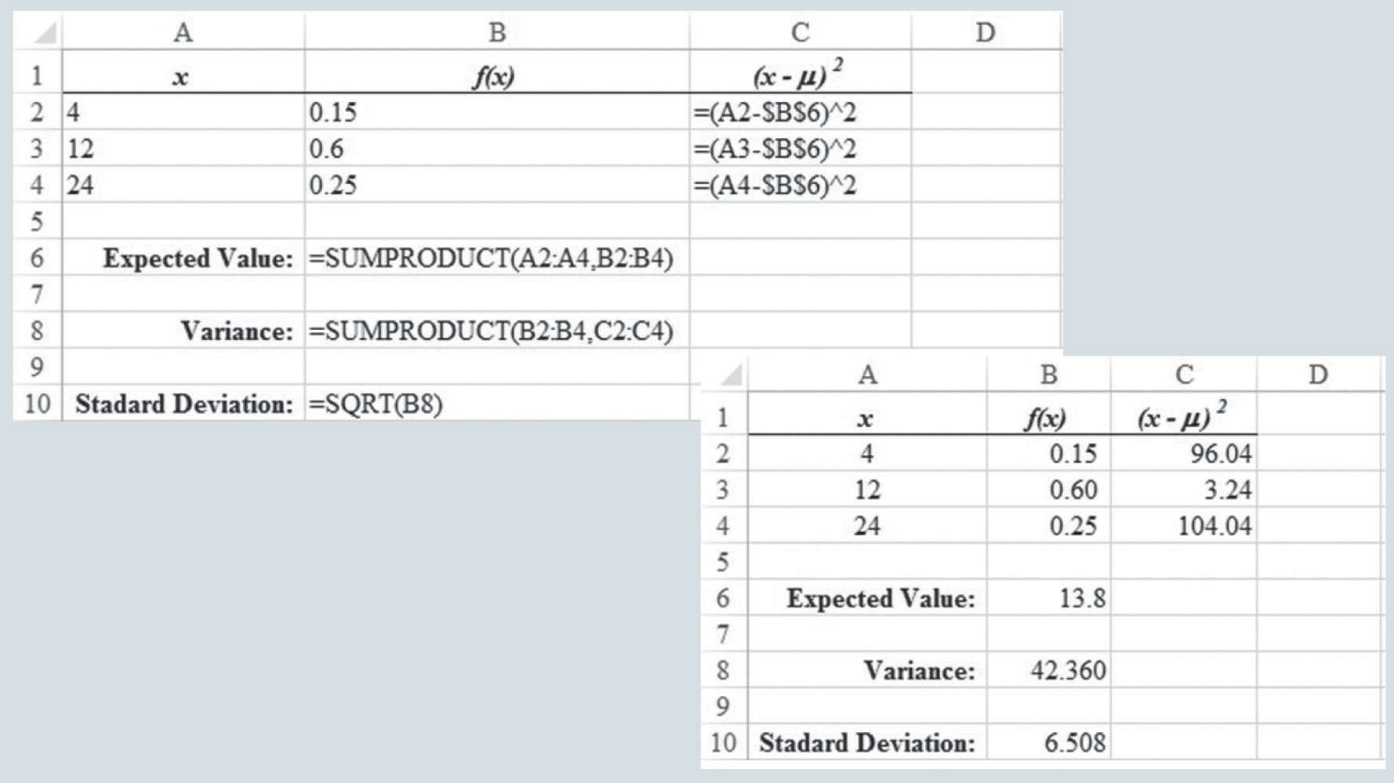

Discrete Probability Distributions

Figure 4.13: Excel Calculation of the Variance for Number of Payments Made per Year by a Lancaster Savings and Loan Mortgage Customer